EXP 10 : Design and implement 3-bit full adder using logisim simulator?

TRUTH TABLE:

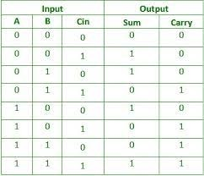

CIRCUIT DIAGRAM:

